**Steps :**

● Install mlflow and required libraries.

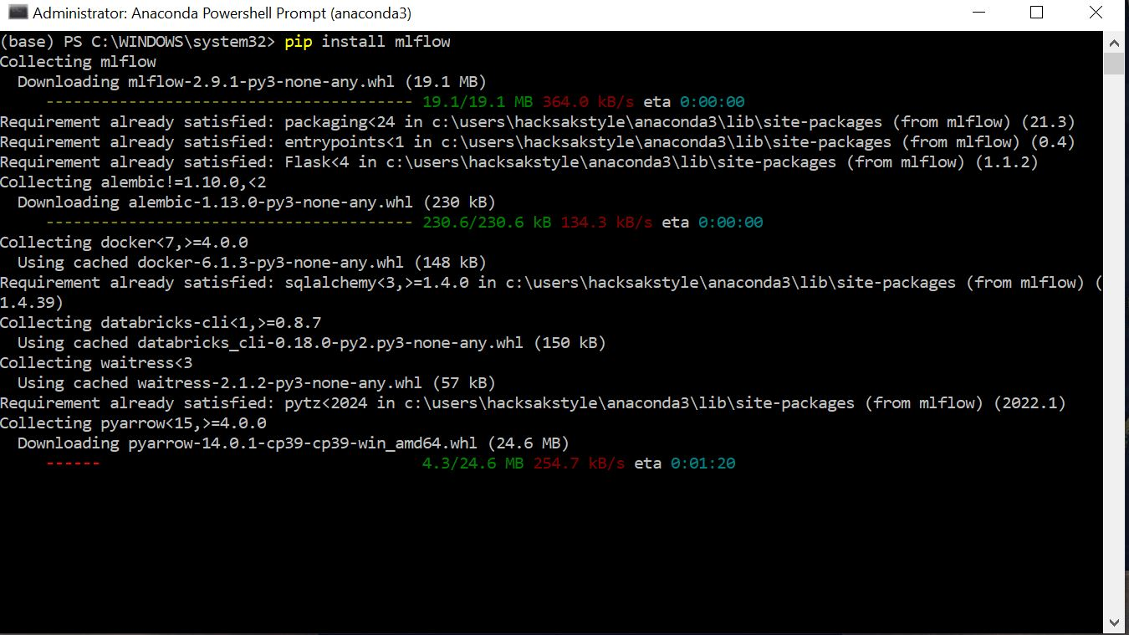

● Load the given data, perform basic EDA, and build a classification model to predict the passengers who survived the titanic shipwreck. (Note:- you can use any classification algorithm you have learned in your previous modules).

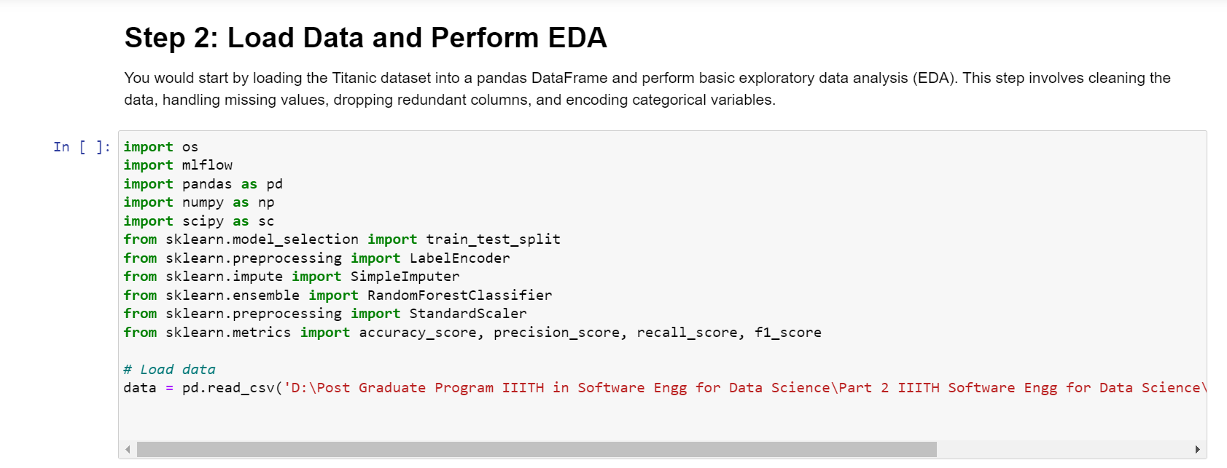

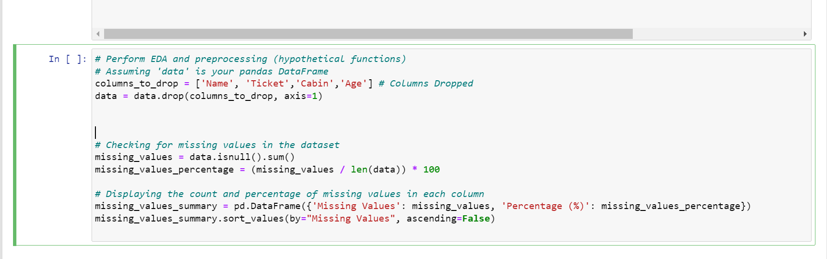

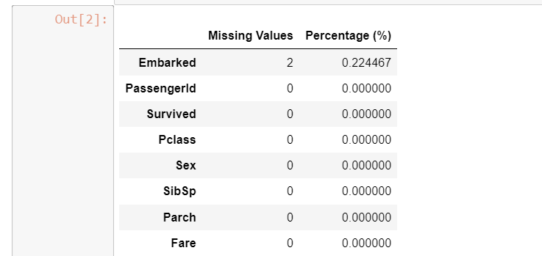

● Log the following parameters using mlflow. (5 points)

a. Hyperparameters (i.e. no. of estimators in case of random forest)

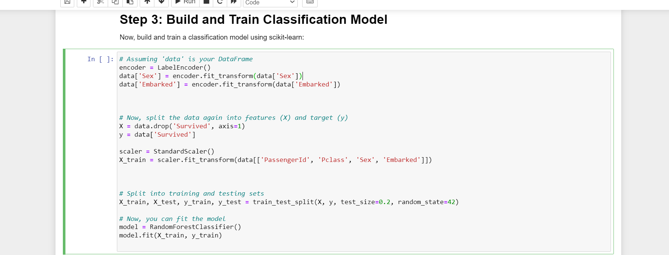

if any b. Evaluation metrics like accuracy, precision, recall, f1 score.

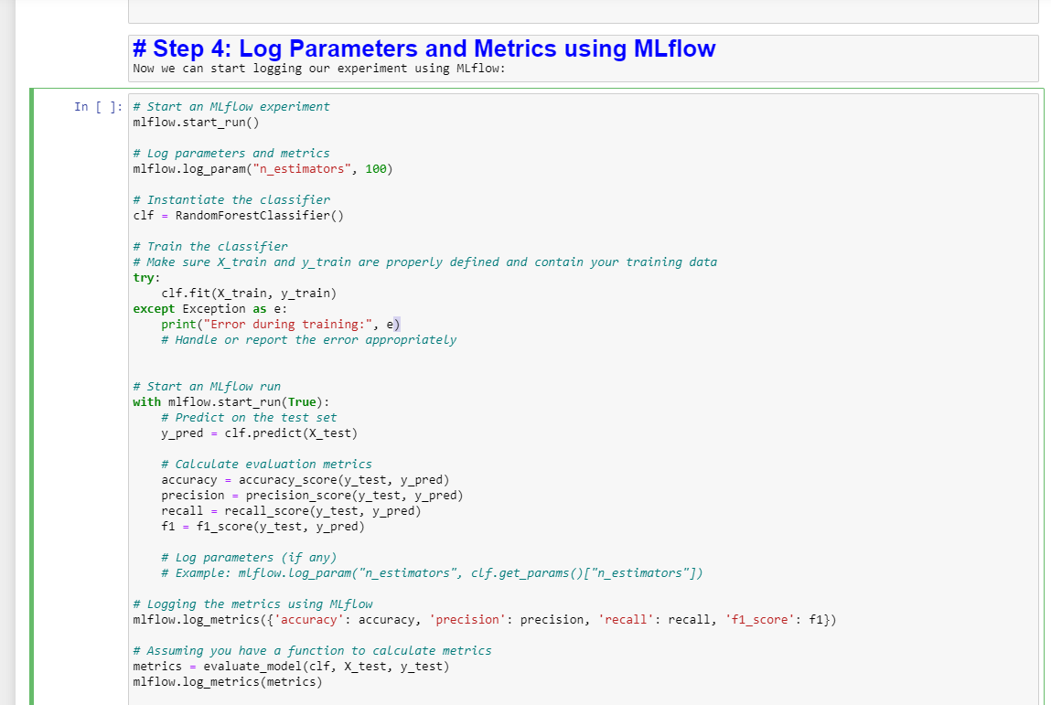

● Run the above model and track the logged parameters in the mlflow ui. (5 points) 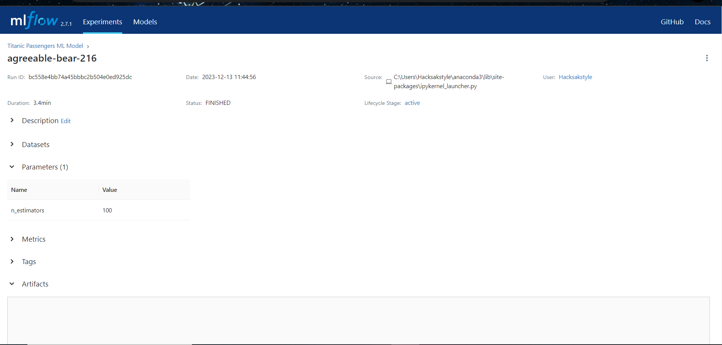

● Make some changes in the model training (like- change a few hyperparameters, train size, etc) and train the updated model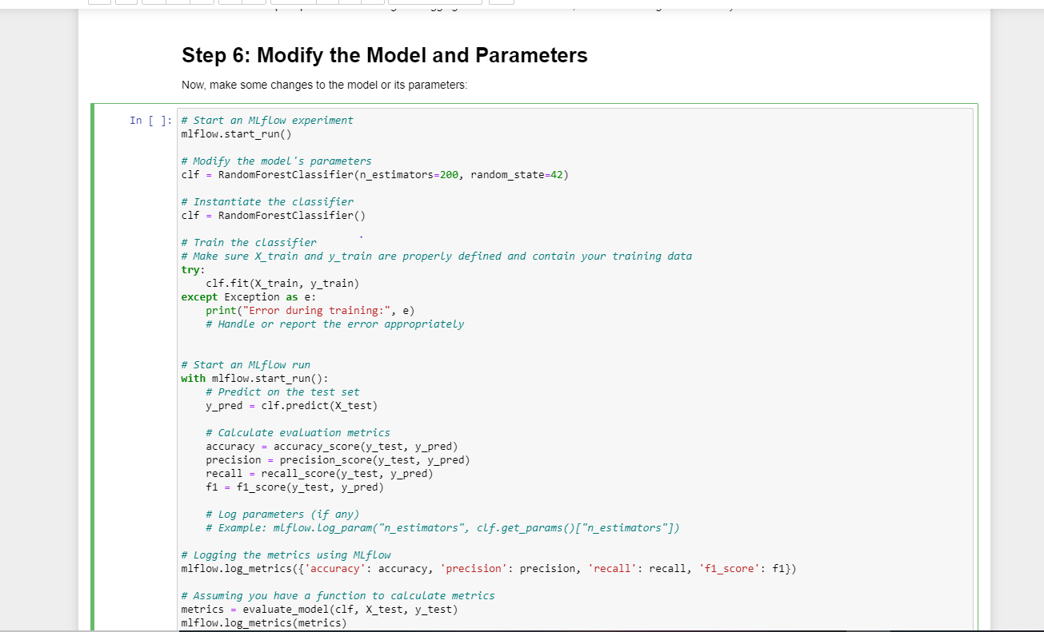

● Track the logged parameters of the second version of the model and compare it with the first model.

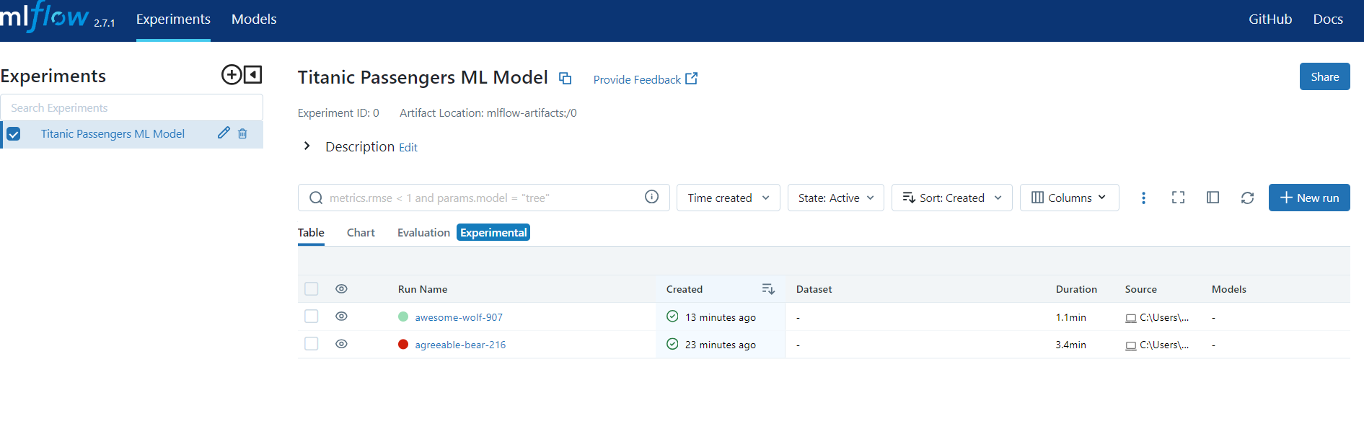

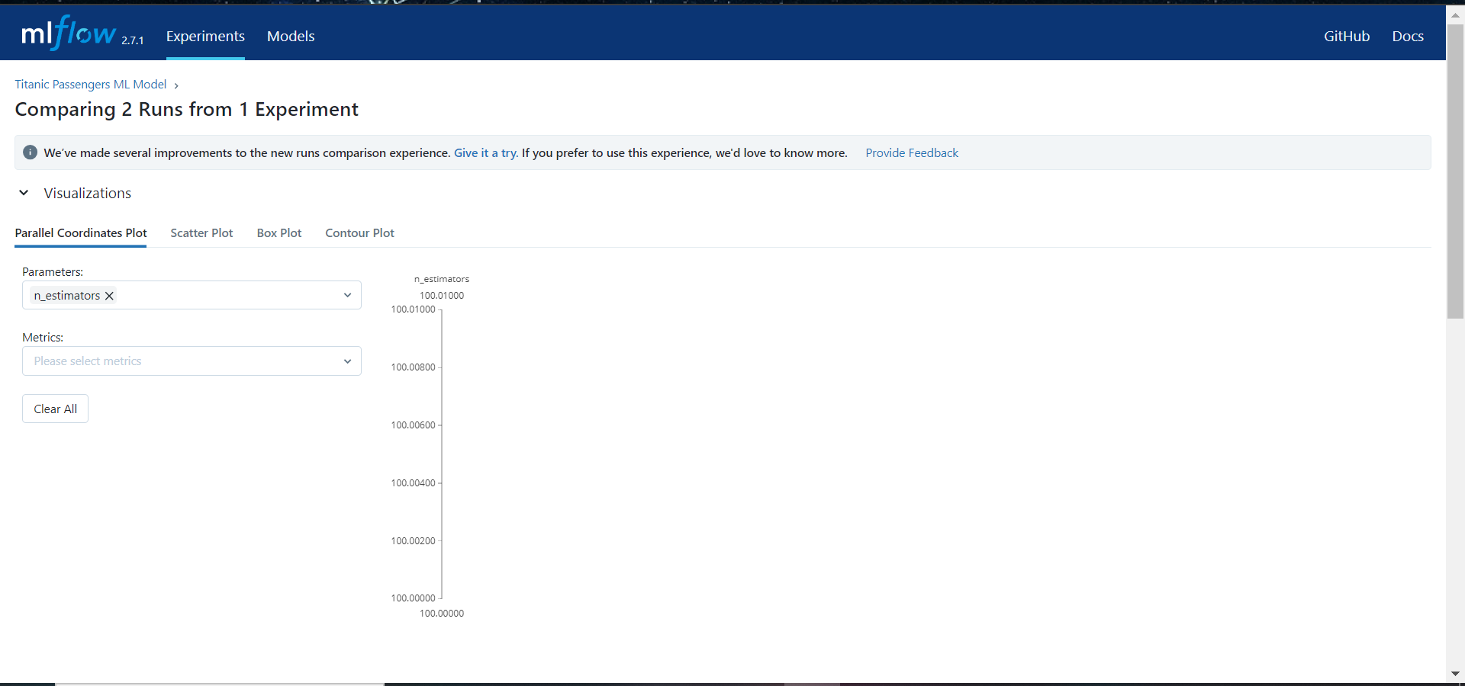

● Serve the model using ML model format with mlflow to deploy a local REST server and pass some sample data and see the predictions. (optional)

